**Project Design Phase-II**

**Data Flow Diagram & User Stories**

|  |  |
| --- | --- |
| Date | 31 Oct 2023 |
| Team ID | NM2023TMID04450 |
| Project Name | Building a website using canva |

**Data Flow Diagrams:**

A Data Flow Diagram (DFD) is a traditional visual representation of the information flows within a system. A neat and clear DFD can depict the right amount of the system requirement graphically. It shows how data enters and leaves the system, what changes the information, and where data is stored.

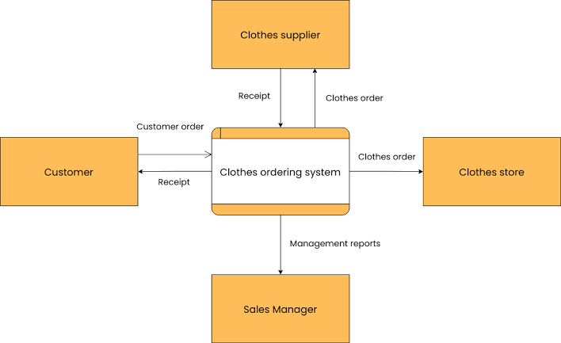

**User Stories**

|  |  |  |  |  |  |  |
| --- | --- | --- | --- | --- | --- | --- |
| **User Type** | **Functional**  **Requirement**  **(Epic)** | **User Story Number** | **User Story / Task** | **Acceptance criteria** | **Priority** | **Team Member** |
| Customer | Registration | USN-1 | I need a user-friendly and intuitive interface that doesn't require extensive coding knowledge. | I can accept the user friendly for intuitive controls. | Medium | Sanmitha |
| Mobile user | Registration | USN-2 | The ability to customize the website's design to reflect my unique style and branding, just like I would with costumes. | I can access the website design for unique style. | High | Nirmala Devi |
| Developer | Registration | USN-3 | The option to maintain a blog or news section for sharing updates, costume design insights, and industry trends. | I can maintain the blog session for continuous industry trends. | High | Janani Susmitha |
| Customer (Web user) | Dash Board | USN-4 | Select a website building platform or content management system (CMS) that suits your needs. | I can access your CMS software should offer you plenty of website design templates to choose from. | Low | Subha Shree |
| Customer Care Executive | Login | USN-5 | Provide a username and password for your account. Ensure the username is unique and memorable. | I can provide a clear security information with unique password. | High | Sanmitha |
| Administrator | Accessing the Resources | USN-6 | Start by gaining a foundational understanding of web development. | I can access the resource by giving the data as an input to the web interface. | Low | Nirmala Devi |
| Service provider | Web application | USN-7 | The prediction and accuracy of the data can be clearly viewed in the application | I can predict the exact output for my input on the crime happened. | High | Janani Susmitha |